

**Building an online sneaker sales system**

**Software Requirement Specification**

– Da Nang, May 2023 –

**Record of changeS**

| **Date** | **A* M, D** | **In charge** | **Change Description** |
| --- | --- | --- | --- |
| 6/5/2023 | A | Mai Văn Tâm | Add Introduction |
| 6/5/2023 | A | Trần Thị Trúc Mai | Add Use Case |
| 6/5/2023 | A | Võ Ngọc Thành | Add Descriptions |
| 6/5/2023 | A | Trần Viết Ngọc Tâm | Add ScreenFlow |
| 6/5/2023 | A | Trịnh Anh Quân | Add Screen Details |
| 6/7/2023 | M | Trần Thị Trúc Mai | Edit Use Case |
| 6/7/2023 | M | Võ Ngọc Thành | Edit Descriptions |
| 6/7/2023 | D | Mai Văn Tâm | Delete Redundant Use Case |
| 6/7/2023 | M | Trần Viết Ngọc Tâm | Edit ScreenFlow |
| 6/7/2023 | D | Trịnh Anh Quân | Delete Redundant Screen |
| 6/9/2023 | A | Trần Viết Ngọc Tâm | Add Description For Functional Requirements |
| 6/9/2023 | A | Võ Ngọc Thành | Add Picture For Functional Requirements |
| 6/9/2023 | A | Mai Văn Tâm | Add Normal Flow For Functional Requirements |
| 6/9/2023 | A | Trịnh Anh Quân | Add Postcondition For Functional Requirements |
| 6/9/2023 | A | Trần Thị Trúc Mai | Add Frequency For Functional Requirements |
| 6/11/2023 | M | Võ Ngọc Thành | Edit Picture For Functional Requirements |
| 6/11/2023 | M | Trịnh Anh Quân | Edit Primary Actor In Functional Requirements |
| 6/11/2023 | A | Mai Văn Tâm | Add Description In Entities Description |
| 6/11/2023 | M | Trần Viết Ngọc Tâm | Edit Database In Entities Description |

*A - Added M - Modified D - Deleted

**Table of Contents**

**I. Overview** **3**

1. Introduction 3

2. User Requirements 4

2.1.Actors 4

2.2. Use cases 5

2.2.1 Diagrams 5

2.2.2 Descriptions 10

3. System Functions 12

a. Screen Flow 12

b. Screen Details 13

c. User Authorization 15

d. Non-Screen Functions 17

4. Entity Relationship Diagram 18

**II. Functional Requirements** **21**

1. Account registration 21

1. Login 22

2. Log out 24

3. Change password 25

5. Forgot password 26

6. View Products 29

7. Search products 30

8. Read contents 31

9. View personal information 32

10. Update personal information 32

11. Purchase 33

12 Choose payment method 35

13. CRUD items in cart 36

14. View purchase history 37

15. Track order 38

16. View contact information 39

17. Chat with the shop 40

18. CRUD Content 42

19. Confirm order 46

20. View order Detail 47

21. Confirm delivery 48

22. Check failed delivery 49

23. CRUD products 50

24. View order status 52

25. View sale history 53

26. View Revenue 54

27. View detail order history 56

28. CRUD employees 57

# 

# 

# 

# I. Overview

## 1. Introduction

The Hipster Shop is an e-commerce website that specialises in selling shoes. It offers various features to support customers throughout the buying and ordering process. This includes browsing the shoe catalogue, searching for specific types or brands of shoes, viewing product images and descriptions, selecting sizes, and placing an order.

Customers can access the website from desktop and mobile web browsers, making it convenient for them to shop from anywhere with an internet connection. The website targets people who enjoy shopping online or need easy access to physical shoe stores nearby. Store owners can also use the website to manage items, process orders, sales, staff, and posts, while content creators can manage articles. Shippers can participate in interactions during the delivery of orders too.

The website assumes that customers have reliable internet connections and are comfortable purchasing online. However, there may be dependencies on other services, such as integration with Gmail for login and QR codes for payment processing.

To ensure a successful launch, it's crucial to conduct user research and testing for usability and functionality before the website goes live. Ongoing maintenance and updates will also be necessary to keep the website safe, fast, and reliable.

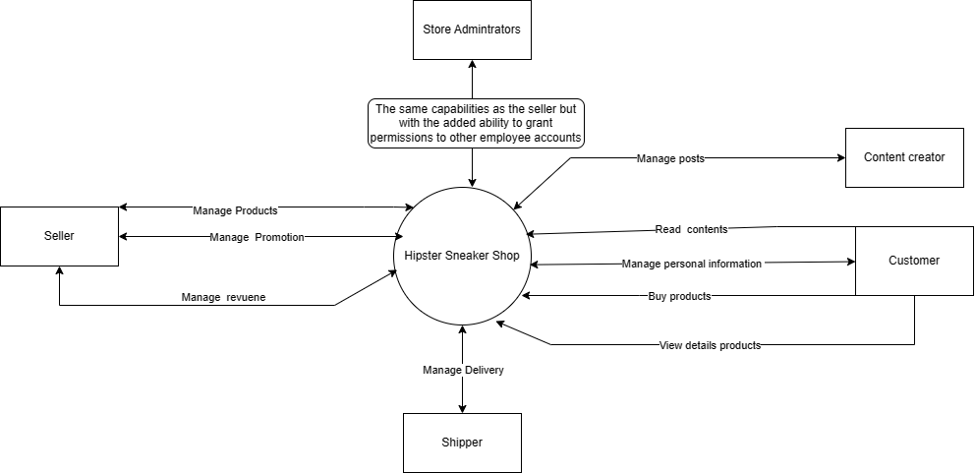

## 2. User Requirements

### 2.1.Actors

| **#** | **Actor** | **Description** |
| --- | --- | --- |
| 1 | Guest | A user who has not logged in to their account on the shoe-selling website. They can view products and product descriptions, but cannot perform shopping activities or manage their personal accounts. |
| 2 | Customer | A user who has registered an account on the shoe-selling website and can perform shopping activities, and manage their account. |
| 3 | Shipper | A person who transports goods from the shop to the customer's delivery address. Able to change the delivery status of the order. Store Administrators authorise the account. |
| 4 | Content Creator | A person who creates promotional content for a product, including images, and articles describing the product. A content creator's mission is to attract customers to the product and help increase sales. Store Administrators authorise the account. |
| 5 | Seller | A person who is responsible for providing detailed information about products, managing orders, managing content, managing coupons, and managing income. The account is authorised by Store Administrators. |
| 6 | Store Administrators | A person who manages and operates the website that sells shoes, with the same capabilities as the seller but with the added ability to grant permissions to other employee accounts. |

### 2.2. Use cases

#### 2.2.1 Diagrams

**Link diagrams**

#### 

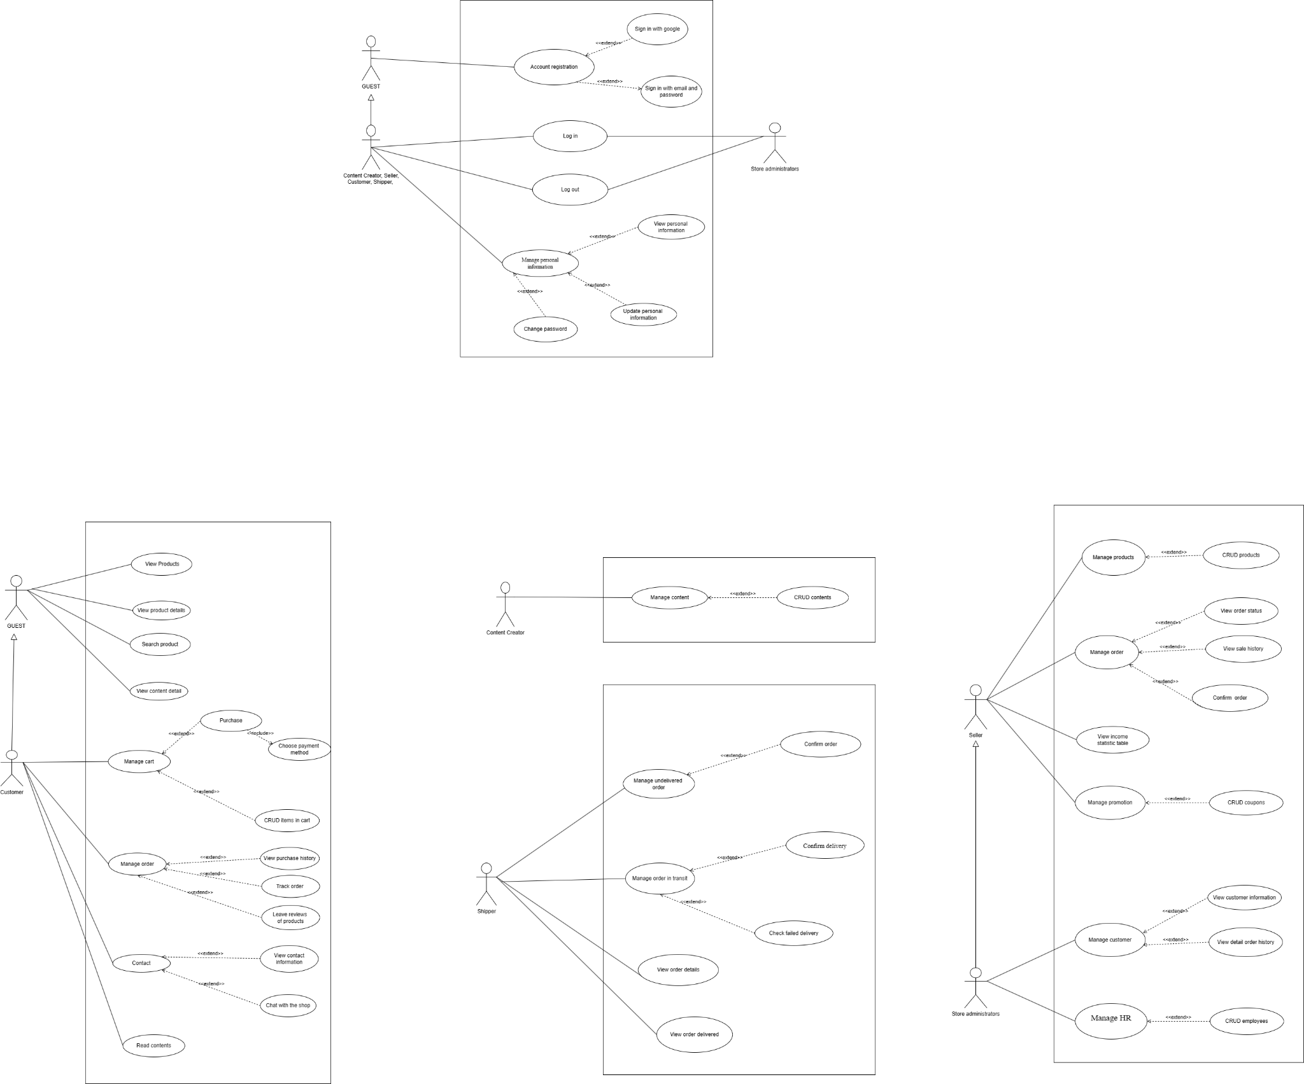

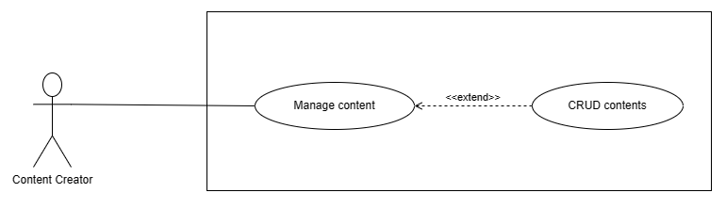

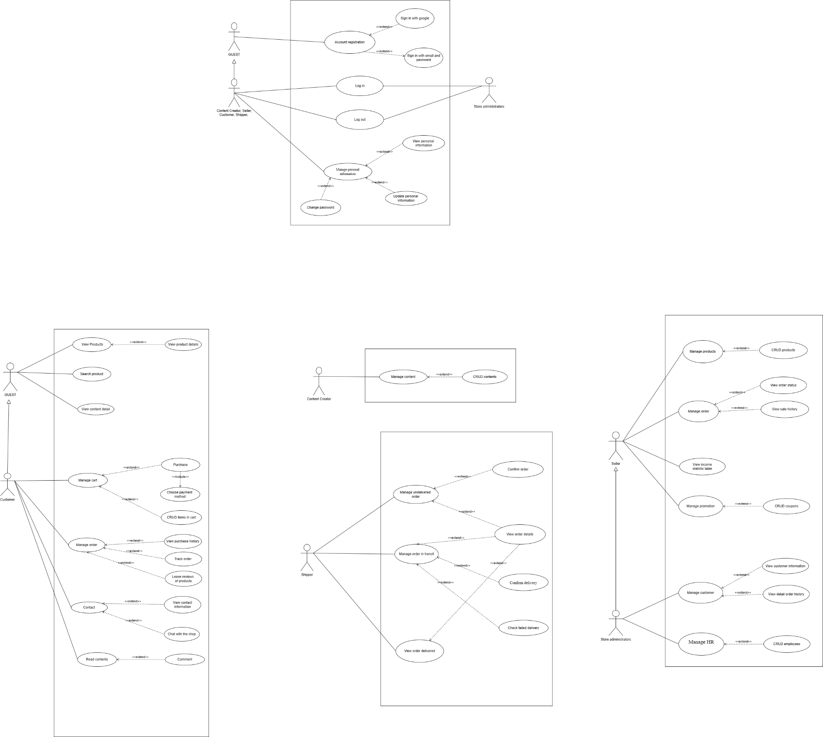



#### 2.2.2 Descriptions

| **ID** | **Use Case** | **Actors** | **Use Case Description** |
| --- | --- | --- | --- |
| UC - 01 | Account registration | Guest | Sign up an account to access the system |
| UC - 02 | Log in | Content creator, Seller, Customer, Shipper, Admin | When actors login of  systems, using the account to access the system |
|
|
|
| UC - 03 | Log out | Content creator, Seller, Customer, Shipper, Admin | Log out from an app or website |
| UC - 04 | Change password | Content creator, Seller, Customer, Shipper, Admin | Let Content creator, Seller, Customer, Shipper change password |
| UC - 05 | Forget password | Content creator, Seller, Customer, Shipper, Admin | Let Content creator, Seller, Customer, Shipper reset their password |
| UC - 06 | View products | Customer, Seller, Admin, Guest | Customer, Seller, Admin can view all the products |
| UC - 07 | Search products | Customer, Seller, Admin, Guest | Customer, Seller, Admin can search the products |
| UC - 08 | Read contents | Customer, Guest | Let Customer and Guest read the content of products, ads, etc.. |
| UC - 09 | View personal information | Content creator, Seller, Customer, Shipper | Content creator, Seller, Customer, Shipper can view detailed personal information |
| UC - 10 | Update personal information | Content creator, Seller, Customer, Shipper | Content creator, Seller, Customer, Shipper can change their personal information |
| UC - 11 | Purchase | Customer | Let them make payment after adding item to cart successfully |
| UC - 12 | Choose payment method | Customer | Offer customers the choice to pay with: Cash; Credit cards |
| UC - 13 | CRUD items in cart | Customer | Allow customer add, delete, update item quantity in the cart |
| UC - 14 | View purchase history | Customer | Let customer view purchase history include products name, quantity, total price, time order |
| UC - 15 | Track order | Customer | Customer can follow all the process of delivering |
| UC - 16 | View contact information | Customer | Let customer view the contact detail of store |
| UC - 17 | Chat with the shop | Customer | Shop chat lets customers reach out to your store through the Shop app. |
| UC - 18 | CRUD content | Content creator | Let Content creator create, update, delete, read content |
| UC - 19 | Confirm order | Shipper | Shipper confirm order before they  they make the delivery |
| UC - 20 | View order details | Shipper | Let shipper view the information of order: receiver, address, total price |
| UC - 21 | Confirm delivery | Shipper | Shipper set the status delivering in the case order in transit |
| UC - 22 | Check failed delivery | Shipper | Shipper set the status for the order in the case the order is not delivered successful |
| UC - 23 | CRUD products | Seller, Admin | Seller, Admin can create, view, update, delete products |
| UC - 24 | View order status | Seller, Admin | Seller, Admin can view the status of the processing order |
| UC - 25 | View sale history | Seller, Admin | Let Seller, Admin view the sale history of products |
| UC - 26 | View revenue | Seller, Admin | Seller, Admin manage the revenue of store by day, week, months |
| UC - 27 | View detail order history | Admin | Allow Admin to view detailed order history for each customer |
| UC - 28 | CRUD employees | Admin | Admin can create, view, update, delete employee |

## 3. System Functions

#### a. Screen Flow

*Link Diagram:* [*https://bom.so/6YqL5i*](https://bom.so/6YqL5i)

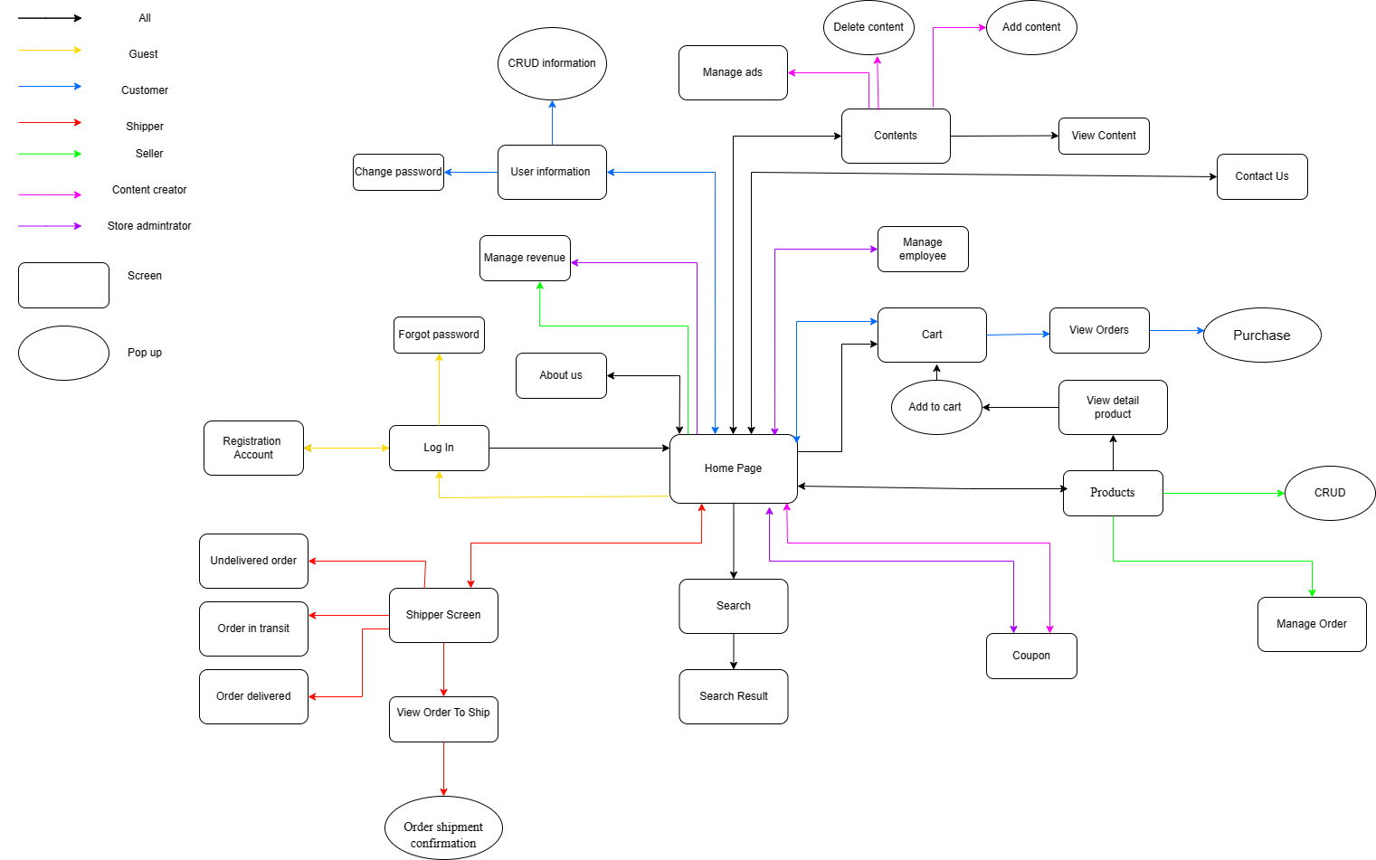

#### b. Screen Details

| **#** | **Feature** | **Screen** | **Description** |
| --- | --- | --- | --- |
| 1 | Login | Login | Users login to the store through the Login Button on the Home page |
| 2 | Change password | Change password | Users clicking on the Change Password option triggers a password modification interface. |
| 3 | Forgot password | Forgot password | At the login page, users can click on the “Forgot password” link to initiate the recovery process. Then, this action will redirect them to a password recovery page. |
| 4 | Register | Register | Users register to the store through the Sign in  Button at the Login page |
| 5 | Edit profile | View Detail Profile | Users who have logged in can see their information in the details profile and modify information |
| 6 | View Products | View Product | Users can view information about the products in the store in the product screen |
| 7 | View Order | View Order | User/Shipper/Seller/Admin can view the orders |
| 8 | View Contents | View Contents | User/content creator/seller/admin can view the content |
| 9 | Confirmation Order | View Order Shipper | The shipper can confirm the status of the orders |
| 10 | Chat | Chat | Users can chat with store staff |
| 11 | View Cart | View Cart | User can see the products that they have added to the cart |
| 12 | CRUD Cart | View Cart | Users can edit the products they have added |
| 13 | CRUD Product | View CRUD Product | seller/admin can edit the products in the store |
| 14 | CRUD Content | View CRUD Content | Content creator/Admin can edit the posted content |
| 15 | Manage employees | Manage employees | Admin can manage the employees in the store |
| 16 | Pay | Payment page | User visits the payment page to pay the order |
| 17 | Order history | View order history | User/shipper/seller/admin can view order history |
| 18 | View coupon | Coupon | User/shipper/seller/admin can view coupon |
| 19 | Manage Revenue | Manage Revenue | Seller/admin can manage store revenue |
| 20 | Manage ads | View manage ads | Content creator/seller/admin can manage ads |
| 21 | CRUD Coupon | View CRUD Coupon | Seller/admin can edit coupon |
| 22 | Contact us | View Contact | User can view the store contact information |

#### c. User Authorization

| **Screen** | **Guest** | **Customer** | **Shipper** | **Content Creator** | **Seller** | **Admin** |
| --- | --- | --- | --- | --- | --- | --- |
| <<Home page>> | X | X | X | X | X | X |
| Contact us | X | X |  |  |  |  |
| Search | X | X |  |  | X | X |
| View featured products | X | X |  |  | X | X |
| Cart |  | X |  |  |  |  |
| <<Login/ Register page>> | X | X | X | X | X | X |
| Login | X | X | X | X | X | X |
| Register | X | X | X | X | X | X |
| Login by social account | X | X | X | X | X | X |
| <<Manage Store page>> |  |  |  |  | X | X |
| View/Create product |  |  |  |  | X | X |
| View/Set Quantity |  |  |  |  | X | X |
| View status |  |  |  |  | X | X |
| View price/set price |  |  |  |  | X | X |
| <<Category page>> |  |  |  |  |  |  |
| View detail products | X | X |  |  | X | X |
| Filter | X | X |  |  | X | X |
| Cart |  | X |  |  |  |  |
| <<Payment page>>> |  | X |  |  |  |  |
| View order |  | X |  |  |  |  |
| Edit information |  | X |  |  |  |  |
| Choose payment method |  | X |  |  |  |  |
| Purchase |  | X |  |  |  |  |
| <<Personal page>> |  | X |  |  |  |  |
| Edit information |  | X |  |  |  |  |
| View order status |  | X |  |  |  |  |
| Chat box (Support) |  | X |  |  |  |  |
| <<Statistic page>> |  |  |  |  | X | X |
| View revenue |  |  |  |  | X | X |
| <<Contact us page>> | X | X |  |  |  |  |
| View maps | X | X |  |  |  |  |
| View information to support | X | X |  |  |  |  |
| <<Coupon page>> |  |  |  |  |  |  |
| Search |  |  |  |  | X | X |
| View/Create coupons |  |  |  |  | X | X |
|  |  |  |  |  |  |  |

#### d. Non-Screen Functions

| **#** | **Feature** | **System Function** | **Description** |
| --- | --- | --- | --- |
| 1 | Log in with Google | Log in | The Google API will allow us to save username and Gmail to the database |

## 4. Entity Relationship Diagram

**Entities Description**

| **#** | **Entity** | **Description** |
| --- | --- | --- |
| 1 | Users | Attributes:   * username -nvarchar(50) * role - nvarchar(50) * password- nvarchar(50) * email - nvarchar(50) * fullname - nvarchar(50) * phone - nvarchar(50) * create_at - datetime * updated_at - datetime * address - nvarchar(50) * Pk (username , email) |
| 2 | Product | Attributes:   * Pk: product_id - int * product_name - nvarchar(50) * product_descripttion - nvarchar(50) * profit_price - float * img - nvarchar(200) * quantity - int * created_at - date * update_at - date * color - nvarchar(50) |
| 3 | Product Detail | Attributes:   * Fk : product_id - int * size - int * quantityOfSize int * orginal_price float * PK(product_id , size) |
| 4 | Order | Attributes:   * pk: order_id -int * username - nvarchar(50) * status- order nvarchar(50) * delivery_address - nvarchar(50) * total_price - float * created_at - date * update_at - date |
| 5 | Order Details | Attributes:   * Fk : order_id -int * Fk: product_id - int * size - int * quantity - int * Pk: (order_id, product_id , size) |
| 6 | Cart | Attributes:   * Pk : cart_id * Fk: username |
| 7 | CartUser | Attributes:   * Fk: cart_id - int * Fk: product_id - int * size - int * quantity int * updated_at date * Pk(cart_id, product_id, size) |
| 8 | ContentCreator | Attributes:   * FK: userId - int * title - nvarchar(50) * img - nvarchar(200) * content - nvarchar(1000) * created_at - datetime * Update_at - datetime |
| 9 | Fee ship | Attribute:   * city_id - int * city * fee_shipping |
| 10 | Price_Table | Attribute:   * id-price - int * Fk: product-id -int * input_price - float * input_Date -date |
| 11 | Rank_Table | Attribute:   * Pk: rankId -int * Fk: username nvarchar(50) * rank - nvarchar(50) |

# II. Functional Requirements

### 1. Account registration

| UC ID and Name | UC - 01 Account registration |
| --- | --- |
| Primary Actor | Guest |
| Description | Register an account for customers who do not have an account to log in to the shop |
| Trigger | Click the “Registration” link |
| Preconditions | PRE-1.1 Guest has a valid email  PRE-1.2 Guest has a valid password  PRE-1.3 Guest has a valid username |
| Postconditions | When normal flow is completed, a new account is created on the system with given information, a new user should be redirected to “Home” page |
| Normal Flow | 1. Access the Hipster Shop website.  2. Click on the sign-in icon to move to the Log-in & Sign-in screen.  3. Fill in the form with your email, user name, and password or click sign in with the Google button  4. Enter or click on the Log-in button to log in to the website or app |
| Exceptions | **Users enter invalid value in register form**  - System shows error messages on each invalid field and prevents guests from submitting the register form  Cannot connect to server or some error occurs  - System shows error messages |
| Priority | High |
| Business Rules | N/a |
| Mockup |  |

### 

### Login

| UC ID and Name | UC - 02 Login | | |
| --- | --- | --- | --- |
| Primary Actor | Content creator | Seller | Customer |
| Shipper | Admin |  |
| Description | Users log in to the store through the Login Button on the Home page. As a Guest, he/she will click on the login button to go to the login page or it will automatically ask him/her to log in when he/she clicks to use the services. | | |
| Trigger | User clicks the button “Login” | | |
| Preconditions | PRE-1: The guest has not logged in the system | | |
| Postconditions | POST-1 The user sign in the system  POST-2. The user is provided access to his allowed systems.  POST-3 The user accesses the system, makes a login request and is directed to the login page. | | |
| Normal Flow | 1. User visits Hipster's original homepage  2. User clicks “Login” button and Hipster returns the information filling page  3. User fills in username and password  4. The system checks the username and password entered in the database.  5. The system returns the home page display corresponding to each role of the registered account. | | |
| Exceptions | Form data is invalid  - System shows error messages below each invalid input field  Account is not exist or the password is incorrect  - System shows error messages | | |
| Priority | Must have | | |
| Business Rules | - Users must enter a valid email address and password to log in.  - The password field should be securely encrypted to protect user data.  - Passwords, username should follow secure password guidelines, such as requiring a minimum length and complexity of characters. | | |
| Mockup |  | | |

### Log out

| UC ID and Name | UC - 03 Logout |
| --- | --- |
| Primary Actor | * Customer * Shipper * Content Creator * Seller * Admin |
| Description | User click on the logout button icon on the home page, system will automatically logout and go to the login page |
| Trigger | User clicks "Logout" button |
| Preconditions | Post 1: User logs into the system  Post 2: User creates a logout request and the system redirects to the login page |
| Postconditions | None |
| Normal Flow | 1. Users access the shop's main platform  2. User clicks the logout box icon  3. The system returns the login page |
| Exceptions | None |
| Priority | High |
| Business Rules | N/a |
| Mockup | None |

### 

### Change password

| UC ID and Name | UC - 04 Change Password | | | |
| --- | --- | --- | --- | --- |
| Primary Actor | Customer, Seller, Content writer, Store Administrators | | | |
|  | Customer | Seller | Content Creator | Store Administrators |
| Description | User wants to change password for their account | | | |
| Trigger | Click the “Registration” link | | | |
| Preconditions | PRE-1. The user is signed into the system | | | |
| Postconditions | POST-1. The user’s password is changed. | | | |
| Normal Flow | 1. User logs in and goes to “Home” page 2. The user clicks on the location of the link "Personal management" and the screen goes to the personal account information management page 3. Click on the link to change the password, the screen will switch to 4. Enter the current password word, the password you want to change, and the new re-password. 5. Click the "update" button | | | |
| Exceptions | * The user does not provide all required fields. * The user does not input the same password for “New password” and “Enter new password again | | | |
| Priority | High | | | |
| Business Rules | N/a | | | |
| Mockup |  | | | |

### 5. Forgot password

| UC ID and Name | UC - 05 Forgot password | | |
| --- | --- | --- | --- |
| Primary Actor | Content creator | Seller | Customer |
| Shipper | Admin |  |
| Description | User forget his/her password and wants to recover his/her password | | |
| Trigger | User click the link “Forgot password”, then user enter valid email and click “Next” button | | |
| Preconditions | Users has a valid email account which has been registered to the website or app | | |
| Postconditions | - System sends an email which contains the reset password link to the provided email  - System redirects the user to the Home Page after reset  password successfully | | |
| Normal Flow: | 1. User at the login page and click "Forgot Password"  2. The screen displays a request to fill in the Gmail/email registered with the system  3. The system notices that a password has been sent to Gmail, User checks the email and fills in the password had sent.  4. Hipster system returns a screen asking for a new password and confirmation. Then the new password will be saved in the database. | | |
| Exceptions | Invalid email or password  - System shows an error message below the invalid fields  The email does not exist on the system  - System shows an error message  New password and confirm password do not match  - System shows an error message  Invalid or expired reset link  - System shows an error message | | |
| Priority | High | | |
| Business Rules | - Users must confirm their current password before changing it.  - Passwords must meet minimum complexity requirements, including a minimum length and a mix of upper and lowercase letters, numbers, and special characters.  - Password changes must be accompanied by an email notification to the user's registered email address. | | |
| Mockup |  | | |

### 6. View Products

### 

| UC ID and Name | UC - 06 View products | |
| --- | --- | --- |
| Primary Actor | Guest | Customer |
| Description | The user wants to see the product list | |
| Trigger | User clicks the "Product" button | |
| Preconditions | User is logged in to the store | |
| Postconditions | None | |
| Normal Flow | 1. The user accesses the shop's website.  2. User clicks "Product" button in home page  3. The system returns the product page | |
| Exceptions | None | |
| Priority | High | |
| Frequency | Users want to view products in shops. | |
| Business Rules | N/a | |
| Mockup |  | |

### 7. Search products

| UC ID and Name | UC - 07 Search products. | |
| --- | --- | --- |
| Primary Actor | Guest | Customer |
| Description | Users who want to search for a certain product will click on the icon button on the Home page, a page will appear for the user to enter the product they want to search for. | |
| Trigger | User clicks on the “Search” button icon. | |
| Preconditions | None | |
| Postconditions | Successful product search. | |
| Normal Flow | 1. The user accesses the shop's website.  2. User clicks on the “Search” button icon on the homepage  3. Enter product information to search.  4. The display screen returns the search product screen. | |
| Exceptions | None | |
| Frequency | Users want to view products in shops | |
| Business Rules | Enter product information to search. | |
| Mockup |  | |

### 8. Read contents

### 

| UC ID and Name | UC - 08 Read contents | |
| --- | --- | --- |
| Primary Actor | Guest | Customer |
| Description | User wants to read post details | |
| Trigger | User clicks on the “continue reading” in the “Blog” page | |
| Preconditions | Visit the home page of shop | |
| Postconditions | The user can read the full content of the content | |
| Normal Flow | 1. Users from the home page click on “Blog” on the navigation bar  2. Go to the “Blog” page and show a list of posted content  3. Click “continue reading” to show full content | |
| Exceptions | N/a | |
| Priority | Medium | |
| Business Rules | N/a | |
| Mockup |  | |

### 9. View personal information

| UC ID and Name | UC - 9 View personal information |
| --- | --- |
| Primary Actor | Customer |
| Description | User wants to see personal information |
| Trigger | User clicks "Profile" button |
| Preconditions | User is logged in to the store |
| Postconditions | None |
| Normal Flow | 1. User clicks on the avatar icon  2. People click the "Profile" button  3. The system redirects to the "Profile" page |
| Exceptions | None |
| Priority | High |
| Business Rules | N/a |
| Mockup |  |

### 10. Update personal information

| UC ID and Name | UC - 11 Update personal information. |
| --- | --- |
| Primary Actor | Customer |
| Description | Users want to change and update account information on the shop |
| Trigger | User clicks the "Profile" button |
| Preconditions | User is logged in to Hipster |
| Postconditions | An alert pops up to update account information successfully |
| Normal Flow | 1. The user accesses the shop's website.  2. User has logged in to the account and into the system.  3. The user clicks on Profile.  4. The screen returns to the Profile screen.  5. The user enters the information he wants to update and presses the Update button to submit. |
| Exceptions | Error entering the wrong old password.  Error not entering domain information. |
| Business Rules | When updating information, the user must enter the correct old password.  Enter complete information about the domain name. |
| Mockup |  |

### 

### 11. Purchase

| UC ID and Name | UC - 12 Purchase |
| --- | --- |
| Primary Actor | Customer |
| Description | Users want to purchase the item in the cart |
| Trigger | User clicks the "Purchase" button |
| Preconditions | User is logged in to Hipster  The account has the item in the cart |
| Postconditions | An alert pops up to confirm the successful purchase.  The paid product will be removed from the cart |
| Normal Flow | 1. User has logged in to the account and into the system.  2. The user clicks on Profile.  3. The screen returns to the Profile screen.  4. The user enters the information he wants to update and presses the Update button to submit. |
| Exceptions | The product is out of stock while still unpaid  The number of products is too large  Query error can't find the product to buy |
| Priority | High |
| Business Rules | Fill in all the necessary information such as the delivery address, phone number, and select a payment method before clicking on the “Pay” button |
| Mockup |  |

### 

### 12 Choose payment method

| UC ID and Name | UC - 13 Choose payment method |
| --- | --- |
| Primary Actor | Customer |
| Description | Customer who wants to choose payment method |
| Trigger | User clicks “Choose payment method” |
| Preconditions | User is logged in to the store |
| Postconditions | None |
| Normal Flow | 1. Customers click the “choose the payment method” in the Shopping cart page. 2. The screen will return the payment methods for the customer to choose |
| Exceptions | None |
| Priority | High |
| Business Rules | N/a |
| Mockup |  |

### 13. CRUD items in cart

| UC ID and Name | UC - 14 CRUD items in cart |
| --- | --- |
| Primary Actor | Customer |
| Description | Customer wants to add the item to cart  Customer want to delete item to cart  Customer wants to update(update size, quantity) of the  item in cart |
| Trigger | Customer click button “add” on card items.  Customer clicks the button “update” in the cart |
| Preconditions | Customer is logged in to the store |
| Postconditions | None |
| Normal Flow | 1. Customers go to the cart in the homepage. 2. Customer select the product who want to edit |
| Exceptions | None |
| Priority | High |
| Business Rules | N/a |
| Mockup |  |

### 14. View purchase history

| UC ID and Name | UC - 15 View purchase history | | |
| --- | --- | --- | --- |
| Primary Actor | Customer | | |
|
| Description | User wants to view purchase history including products name, quantity, total price, and time order | | |
| Trigger | Click on logo “Login”, it contains receipt option | | |
| Preconditions | User must login in | | |
| Postconditions | User must buy item | | |
| Normal Flow | 1. User has logged in to the account and into the system, then the user clicks on logo “Login”, it contains the receipt option, user click receipt option.  2. The screen returns to the receipt screen.  3. The user will see all of the order that they had bought | | |
| Exceptions | None | | |
| Priority | High | | |
| Business Rules | None | | |
| Mockup |  | | |

### 15. Track order

| UC ID and Name | UC - 16 Track order |
| --- | --- |
| Primary Actor | Customer |
| Description | Customer can follow all the processes of delivering |
| Trigger | “Order Status” option in “Personal Information” |
| Preconditions | User is logged in to the store  User whose order has been paid and is being shipped has been successfully deleted from the cart |
| Postconditions | After the process runs out, the goods will arrive at the delivery place |
| Normal Flow | 1. Go to the home page  2.Click on “personal information” and click on the link “ordered order”  3.Follow up on orders being placed and delivered |
| Exceptions | The application has been delivered but has not changed the status of “successfully delivered” |
| Priority | High |
| Business Rules | N/a |
| Mockup |  |

### 

### 16. View contact information

| UC ID and Name | UC - 17 View contact information. | |
| --- | --- | --- |
| Primary Actor | Guest | Customer |
| Description | Users who want to see the shop's Contact Us will click the Contact Us button on the Home page, which will bring up a Contact Us page. | |
| Description | Users want to view Contact Us in shops | |
| Preconditions | None | |
| Postconditions | View contact information successfully. | |
| Normal Flow | 1. The user accesses the shop's website.  2. User clicks on the “Contact Us” button on the homepage  3. The display screen returns the Contact Us screen. | |
| Exceptions | None | |
| Frequency | Users want to view Contact Us in shops. | |
| Business Rules | None | |
| Mockup |  | |

### 17. Chat with the shop

| UC ID and Name | UC - 18 Chat with the shop |
| --- | --- |
| Primary Actor | Customer |
| Description | User wants to chat with the store |
| Trigger | User clicks icon "Chat" button |
| Preconditions | User is logged in to the store |
| Postconditions | None |
| Normal Flow | 1. User clicks on the chat icon  2. The system will display a chat box |
| Exceptions | None |
| Priority | High |
| Business Rules | N/a |
| Mockup |  |

### 18. CRUD Content

| UC ID and Name | UC-19-01 Create content |
| --- | --- |
| Primary Actor | Content creator |
| Description | Content creator want to create new content |
| Trigger | Content creator clicks on the "Add Content" button |
| Preconditions | Content creator is logged in to the system |
| Postconditions | Content creator create new content successfully and saved in database |
| Normal Flow | 1. Content creator go to Hipster's original homepage and log in  2. Hipster system returns the homepage of the Content creator screen  3. Content creator presses the "Content" button  4. The system returns the screen showing the list of content available on the system  5. Content creator can create new Content through “Add content” button  6. Content creator fill in new Content and press + button to add new Content into system and database |
| Exception | None |
| Priority | High |
| Business Rules | BR1: Content limit of each article is 3000 words  BR2: The image must be png |
| Mockup |  |

| UC ID and Name | UC-19-02 Read content |
| --- | --- |
| Primary Actor | Content creator |
| Description | Content creator want to view content |
| Trigger | Content creator clicks on the "Content" tab in their screen |
| Preconditions | Content creator is logged in to the system |
| Postconditions | System displays a list of all content's information. |
| Normal Flow | 1. Content creator go to Hipster's original homepage and log in  2. The hipster system returns the homepage of the Content creator screen  3. Content creator presses the "Content" tab  4. The system returns the screen showing the list of content available on the system  5. The content creator can view all of the contents |
| Exception | None |
| Priority | High |
| Business Rules | BR1: Content limit of each article is 3000 words  BR2: The image must be png |
| Mockup |  |

| UC ID and Name | UC-19-03 Update content |
| --- | --- |
| Primary Actor | Content creator |
| Description | Content creator want to update content which had in the system |
| Trigger | Content creator clicks on the button  to update |
| Precondition | Content creator is logged in to the system |
| Postconditions | Content creator update content successfully and saved in database |
| Normal Flow | 1. Content creator go to Hipster's original homepage and log in  2. Hipster system returns the homepage of the Content creator screen  3. Content creator presses the "Content" tab  4. The system returns the screen showing the list of content available on the system  5. Content creator can can see and read list of Content on the screen  6. Content creator press  in the Action to update. |
| Exception | None |
| Priority | High |
| Business Rules | BR1: Content limit of each article is 3000 words  BR2: The image must be png |
| Mockup |  |

| UC ID and Name | UC-19-04 Delete content |
| --- | --- |
| Primary Actor | Content creator |
| Description | Content creator want to delete content which had in the system |
| Trigger | Content creator want to delete content which had in the system |
| Preconditions | Content creator is logged in to the store |
| Postconditions | Content creator deletes content successfully |
| Normal Flow | 1. Content creator go to Hipster's original homepage and log in  2. The Hipster system returns the homepage of the Content Creator screen  3. Content creator presses the "Content" tab  4. The system returns the screen showing the list of content available on the system  5. The content creator can can see and read the list of Content on the screen  6. Content creator press  in the Action to delete. |
| Exceptions | None |
| Priority | High |
| Business Rules | N/a |
| Mockup |  |

### 19. Confirm order

| UC ID and Name | UC - 20 Confirm order |
| --- | --- |
| Primary Actor | Shipper |
| Description | The shipper will confirm the order after receiving the goods and agree to deliver |
| Trigger | The shipper clicks the “confirm” after checking the product in the order. |
| Preconditions | The shipper need to login to the store |
| Postconditions | Confirm the order successfully. |
| Normal Flow | 1. Shipper goes to the page of shipper. 2. view the order needed to confirm in the store. 3. The shipper clicks to confirm the order after receiving the goods and delivering the goods 4. The screen return confirms success. |
| Exceptions | None |
| Priority | High |
| Business Rules | N/a |
| Mockup |  |

### 20. View order Detail

| UC ID and Name | UC - 21 View order details |
| --- | --- |
| Primary Actor | Shipper |
| Description | Shipper wants to view order details, to to check delivered products |
| Trigger | Shipper clicks the order to view details |
| Preconditions | Shipper needs to login to the store |
| Postconditions | None |
| Normal Flow | 1. Shipper choose confirmed order to see details 2. The screen returns the details order . |
| Exceptions | None |
| Priority | High |
| Business Rules | N/a |
| Mockup |  |

### 21. Confirm delivery

| UC ID and Name | UC - 22 Confirm delivery |
| --- | --- |
| Primary Actor | Shipper |
| Description | Shipper set the status delivering in the case order in transit |
| Trigger | Shipper clicks the “Delivering” button to set the status for the order.  Shipper clicks “Successful delivery” to set the status for the order. |
| Preconditions | Shipper needs to confirm the order. |
| Postconditions | None |
| Normal Flow | 1. Shipper selects the order and clicks “Delivering ” . 2. Shipper clicks “successful delivery” after delivery is successful. |
| Exceptions | None |
| Priority | High |
| Business Rules | N/a |
| Mockup |  |

### 22. Check failed delivery

| UC ID and Name | UC - 23 Check failed delivery |
| --- | --- |
| Primary Actor | Shipper |
| Description | Shipper wants to confirm delivery failed |
| Trigger | Shipper clicks on order status in shipper page and clicks "Delivery Failed" |
| Precondition | Shipper login to shipper page |
| Postconditions | None |
| Normal Flow | 1. Shipper login to the shipper page  2. Shipper click on order status in shipper page  3. Shipper click "Delivery Failed" |
| Exceptions | None |
| Priority | High |
| Business Rules | N/a |
| Mockup |  |

### 23. CRUD products

| UC ID and Name | UC - 24 CRUD products | |
| --- | --- | --- |
| Primary Actor | Seller | Admin |
| Description | The manager wants to CRUD the products in the store | |
| Trigger | The manager goes to the product section in the management page and chooses to edit the product | |
| Preconditions | Management login to the management page | |
| Postconditions | None | |
| Normal Flow | 1. Manage login to the management page  2. The manager selects the product you want to edit  3. Product Editing Manager | |
| Exceptions | None | |
| Priority | High | |
| Business Rules | N/a | |
| Mockup |  | |

### 24. View order status

| UC ID and Name | UC - 25 View order status | |
| --- | --- | --- |
| Primary Actor | Customer | Seller |
| Description | Users want to see the status of their product orders in the shop, then click on the customer information icon button icon. Then will be transferred to the View Order Status page, the customer's product order status will be displayed and can be viewed by the user | |
| Trigger | Users want to view order status in shops | |
| Preconditions | User is logged in to Hipster | |
| Postconditions | View order status successfully | |
| Normal Flow | 1. The user accesses the shop's website.  2. The user logs into his account and enters the system.  3. The user clicks on my account.  4. Continues to click View order status.  5. The screen returns the View order status. | |
| Exceptions | The user is not logged in to the system.  The user has not placed an order in the store. | |
| Priority | High | |
| Business Rules | The user must log in to the system. | |
| Mockup |  | |

### 

### 

### 25. View sale history

| UC ID and Name | UC - 26 View sale history | |
| --- | --- | --- |
| Primary Actor | Seller | Store Administrators |
| Description | The user wants to see the history of the products sold in the store | |
| Trigger | Users want to view View sales history in shops. | |
| Preconditions | User is logged in to the Hipster Store. | |
| Postconditions | View sale history successfully. | |
| Normal Flow | 1. The user accesses the shop's website.  2. User logs into the account and enters the system.  3 Then User clicks on my account.  4. Continues to click View sales history.  5. The screen returns the historical status of the sold products of the seller.  6. Users can use order no to search for products or can search by date. | |
| Exceptions | The user is not logged in to the system.  The user doesn't have a product for sale in the store yet. | |
| Business Rules | The user must log in to the system.  The user has sold the products in the store. | |
| Mockup |  | |

### 26. View Revenue

| UC ID and Name | UC - 27 View revenue | |
| --- | --- | --- |
| Primary Actor | Seller | Store Administrators |
| Description | The user wants to view revenue of the products that have been sold in the store. Users can look up revenue history by looking up by date | |
| Trigger | Users want to view View revenue in shops | |
| Preconditions | The user is logged in to the Hipster Store | |
| Postconditions | View detail order history successfully  The products in the store have been sold | |
| Normal Flow | 1. User logs into my account and enters the system  2. Then the User clicks on my account  3. Continues to click Manage Revenue  4. The screen will display the revenue of the sold products | |
| Exceptions | The store has not sold the product yet | |
| Business Rules | The user must log in to the system.  The user has sold the products in the store. | |
| Mockup |  | |

### 

### 

### 

### 

### 

### 

### 

### 

### 

### 

### 

### 

### 

### 

### 

### 

### 

### 

### 27. View detail order history

| UC ID and Name | UC - 28 View detail order history |
| --- | --- |
| Primary Actor | Customer |
| Description | The user wants to see the history of the products ordered in the store. Users can look up the history of orders placed by entering the order id and can look up by date |
| Trigger | Users want to view View detailed order history in shops |
| Preconditions | The user is logged in to the Hipster Store.  The user has placed an order in the store. |
| Postconditions | View detail order history successfully. |
| Normal Flow | 1. User logs into my account and enters the system  2. Then the User clicks on my account  3. Continues to click View detailed order history.  4. The screen returns the history status of the purchased products of the buyer. |
| Exceptions | The user has not placed an order. |
| Business Rules | The user must log in to the system.  The user has sold the products in the store. |
| Mockup |  |

### 

### 

### 28. CRUD employees

| UC ID and Name | UC - 29 CRUD employees |
| --- | --- |
| Primary Actor | Store administrators |
| Description | The store administrator is the person who has the right to manage the overall sales website. Store administrator has the right to create, add, edit, and delete employees on the store's website. |
| Trigger | The user clicks on the login button, the login account must be the administrator account of the website. |
| Preconditions | The user has logged into the system. |
| Postconditions | Users must log in to the system.  The user account must be the system admin account. |
| Normal Flow | 1. The user accesses the shop's website.  2. The user clicks on the icon button to log in to the system, the login account must be the StThe administrators account.  3. Once logged in, the user will be redirected to the admin page.  4. Users can click CRUD employees in the store. |
| Exceptions | User is logged in with the correct account.  User error when CRUD employees. |
| Business Rules | Log in with the correct Store Administrator account.  When RUD employees must have an account in the system. |
| Mockup |  |